Case Study Report

Data Analytics with Power BI

**“Analysis of Commercial Electricity Consumption in Indian State”**

**“Sri paramakalyani college,alwarkurichi”**

|  |  |
| --- | --- |
| **NM ID** | **NAME** |
| **BDDA10B0068062183E94894ED51F67E2** | **K.ESAKKI PANDIAN** |

|  |
| --- |
| Trainer Name: R UMAMAHESWARI |
| Master Trainer: R UMAMAHESWARI |

ABSTRACT

This study investigates the patterns and determinants of commercial electrical consumption across various states in India. Utilizing comprehensive datasets spanning multiple years, the research employs statistical analysis and econometric models to identify key factors influencing commercial electricity usage. Factors such as economic growth, industrial activity, urbanization, and policy interventions are examined to understand their impact on commercial energy demand. The findings reveal significant variations in consumption patterns among states, influenced by diverse socio-economic and infrastructural characteristics. Additionally, the study assesses the implications of these consumption trends on energy sustainability, economic development, and environmental concerns. The insights derived from this analysis can inform policymakers, utility providers, and stakeholders in devising targeted strategies to optimize energy usage, promote efficiency measures, and mitigate environmental impacts in the commercial sector across Indian states.

# INDEX

|  |  |  |
| --- | --- | --- |
| **S.No.** | **Table of Contents** | **Page No.** |
| 1 | Chapter 1: Introduction | 4 |
| 2 | Chapter 2: Services and Tools Required | 6 |
| 3 | Chapter 3: Project Architecture | 8 |
| 4 | Chapter 4: Modeling and Result | 11 |
| 5 | Conclusion | 21 |
| 6 | Future Scope | 22 |
| 7 | References | 23 |
| 8 | Links | 23 |

**CHAPTER 1 INTRODUCTION**

Electrical consumption, also known as electricity consumption, refers to the amount of electricity consumed by various entities, including residential, commercial, and industrial sectors, to power appliances, machinery, lighting, and other electrical devices. It is a fundamental aspect of modern society, driving economic activities, improving living standards, and enabling technological advancements.

# KEY ASPECTS

1. **Residential Consumption:** Residential electrical consumption encompasses electricity usage within households for lighting, heating, cooling, cooking, entertainment, and other daily activities. It varies based on factors such as household size, location, climate, and lifestyle choices.
2. **Commercial Consumption:** Commercial electrical consumption involves electricity usage by businesses, offices, retail establishments, and other commercial entities for lighting, heating, air conditioning, computing, manufacturing processes, and other operational needs. It is influenced by factors like business size, industry type, operating hours, and technological infrastructure.
3. **Industrial Consumption:** Industrial electrical consumption is the usage of electricity by manufacturing plants, factories, and industrial

facilities for powering machinery, equipment, production processes, and auxiliary systems. It constitutes a significant portion of total electrical consumption and is influenced by factors such as production output, automation levels, and energy efficiency measures.

1. **Public Sector Consumption:** Public sector electrical consumption includes electricity usage by government offices, educational institutions, healthcare facilities, and other public services. It covers a wide range of activities, including administration, education, healthcare delivery, and public infrastructure maintenance.
2. **Transportation Sector:** While not traditionally considered a primary sector of electrical consumption, the transportation sector is increasingly integrating electric vehicles (EVs) for automobiles, buses, trains, and other modes of transport. Electric vehicle charging infrastructure and energy consumption patterns are becoming significant considerations in overall electrical consumption trends.

# Factors Influencing Electrical Consumption:

**Economic Growth:** Economic development and industrialization drive increased demand for electricity as businesses expand, and consumers adopt more electrical appliances and services.

**Population Growth:** Growing populations lead to higher residential and commercial electricity consumption as more households and businesses require electricity to meet their needs.

**Technological Advances:** Technological innovations, such as energy- efficient appliances, LED lighting, and smart devices, influence electrical consumption patterns by reducing energy usage per unit of output.

**Policy and Regulation:** Government policies, energy efficiency standards, pricing mechanisms, and renewable energy mandates can shape electrical consumption trends by incentivizing conservation, promoting renewable energy adoption, and influencing consumer behavior.

**Climate and Geography:** Climate conditions, seasonal variations, and geographical factors affect electrical consumption patterns, such as higher usage of air conditioning in hot climates or heating in cold regions.

# CHAPTER 2

**SERVICES AND TOOLS REQUIRED**

By leveraging these services and tools, you can create a comprehensive case study on power consumption using Power BI. You can analyse historical consumption data, identify trends and patterns, visualize energy usage across different time periods and locations, and derive actionable insights to optimize energy efficiency and reduce costs.

1. **Power BI Desktop:** Power BI Desktop is a free desktop application that allows you to create data visualizations and reports. You can import data from various sources, transform it, and create interactive dashboards and reports.
2. **Data Sources:** Gather data related to power consumption from sources such as utility companies, smart meters, IoT devices, energy management systems, and historical records. Ensure that the data is comprehensive and covers relevant time periods and geographical locations.
3. **Power BI Service (Power BI Online):** Once you've created your reports and dashboards in Power BI Desktop, you can publish them to the Power BI Service. The Power BI Service is a cloud-based platform where you can share, collaborate, and access your reports and dashboards from any device with an internet connection.
4. **Microsoft Azure:** Azure provides various services that can complement Power BI for advanced analytics and data processing. For example, you can use Azure SQL Database to store large volumes of data related to power consumption or Azure Analysis Services to perform complex calculations and modelling.
5. **Power BI Embedded:** If you're developing a custom application or website and want to embed Power BI reports and dashboards directly into your application, you can use Power BI Embedded. This service allows you to integrate Power BI visuals seamlessly into your application's user interface.
6. **Power BI Mobile App:** The Power BI Mobile App allows you to view and interact with your Power BI reports and dashboards on your mobile device. This is useful for accessing real-time insights and monitoring power consumption while on the go.
7. **Power BI Templates:** Power BI Templates are pre-built report templates that you can customize for your specific use case, such as power consumption analysis. You can find templates related to energy management and sustainability in the Power BI community gallery or create your own templates based on your requirements.
8. **Data Sources:**

# CHAPTER 3

**PROJECT ARCHITECTURE**

Smart Meters: Collect real-time data on electricity consumption from smart meters installed at various locations, such as residential buildings, commercial establishments, and industrial facilities.

IoT Devices: Utilize Internet of Things (IoT) devices equipped with sensors to monitor energy usage, temperature, and other relevant parameters.

Utility Companies: Access historical consumption data and billing information from utility companies through APIs or data exports.

Historical Records: Gather historical data on power consumption from databases, spreadsheets, or legacy systems.

## Data Ingestion and Integration:

Use Power BI Desktop or other ETL (Extract, Transform, Load) tools to ingest data from different sources.

Cleanse, transform, and integrate the data to ensure consistency and accuracy.

Store the processed data in a suitable data storage solution, such as Azure SQL Database, Azure Data Lake Storage, or Power BI Dataflows.

## Data Modelling and Preparation:

Define data models to represent the relationships between different entities, such as meters, locations, time periods, and consumption metrics.

Create calculated columns, measures, and hierarchies to facilitate analysis and visualization.

Optimize data models for performance and scalability, considering factors like data volume and query complexity.

## Analysis and Visualization:

Develop interactive reports and dashboards in Power BI Desktop.

Use a variety of visualizations, including line charts, bar charts, maps, and gauges, to represent consumption data.

Incorporate slicers, filters, and drill-downs to enable users to explore data from different perspectives and levels of detail.

Implement calculated fields and KPIs to highlight key metrics, such as peak demand, average consumption, and cost trends.

## Deployment and Publishing:

Publish the reports and dashboards to the Power BI Service for sharing and collaboration.

Configure access permissions to control who can view, edit, and share the content.

Schedule data refreshes to ensure that the reports reflect the latest consumption data.

## Consumption Monitoring and Alerting:

Set up alerts and notifications to monitor consumption patterns and detect anomalies or deviations from expected behavior.

Use Power BI's built-in alerting capabilities or integrate with external monitoring tools for real-time alerting.

## Mobile Access and Distribution:

Enable access to reports and dashboards on mobile devices using the Power BI Mobile App.

Distribute insights and findings to stakeholders via email subscriptions, embedded reports, or custom applications.

## Continuous Improvement and Optimization:

Gather feedback from users and stakeholders to identify areas for improvement and optimization.

Iteratively refine the data models, visualizations, and analysis techniques based on user requirements and business objectives.

Leverage Power BI's monitoring and usage analytics to track adoption and performance metrics over time.

By following this architecture, organizations can effectively leverage Power BI to create insightful and actionable analyses of power consumption data, driving informed decision-making and promoting energy efficiency initiatives.

# CHAPTER 4 MODELING AND RESULT

* 1. **IMPORT THE DATA:**

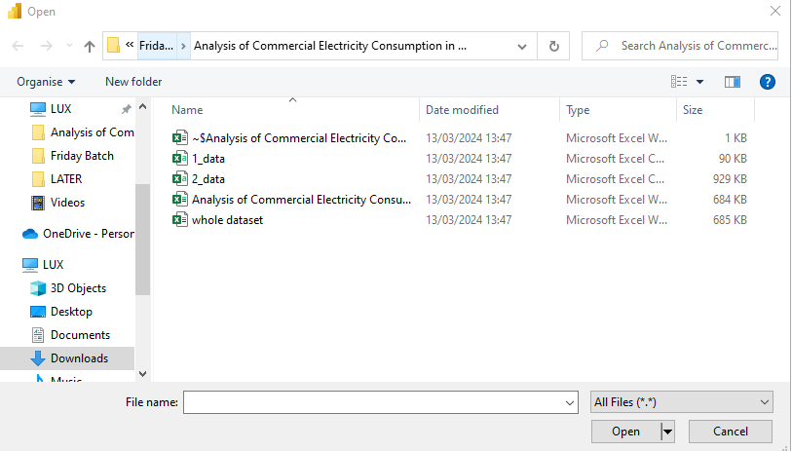

# LOADING THE DATA:

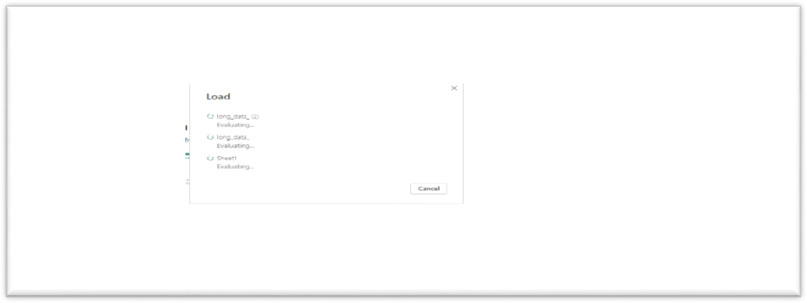

* 1. **VIEW OF DATA:**

Once the data is loaded it is viewed on the right-side corner of the tab and the left side visulation is shown we can choose any one of them and we can make our project or report or anything else.

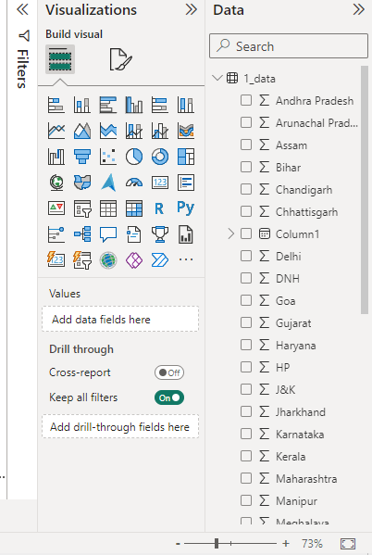

# MAPPING AND MAPPING RELATION: MAPPING:

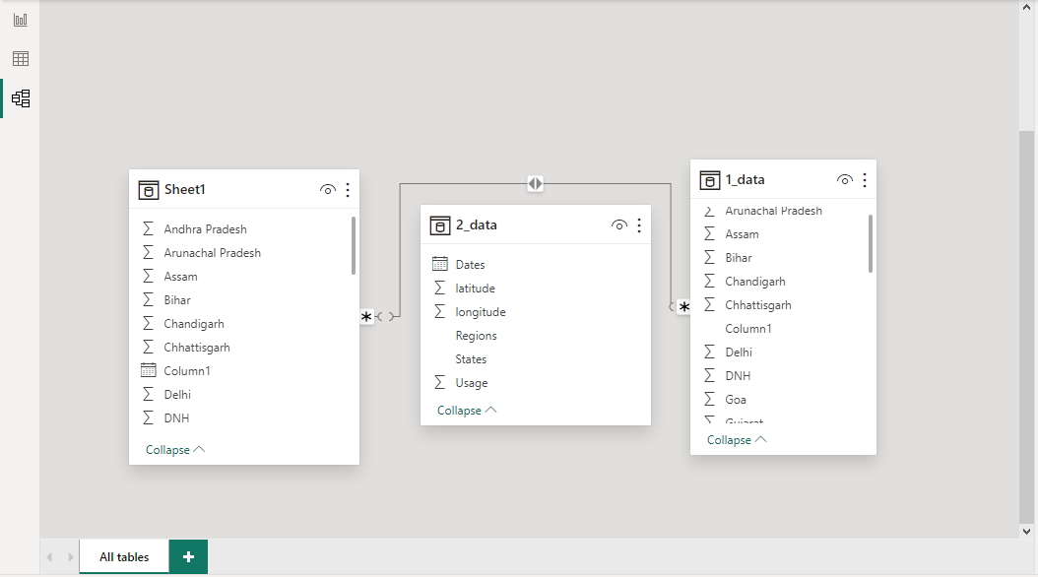

EDIT MAPPING RELATION:

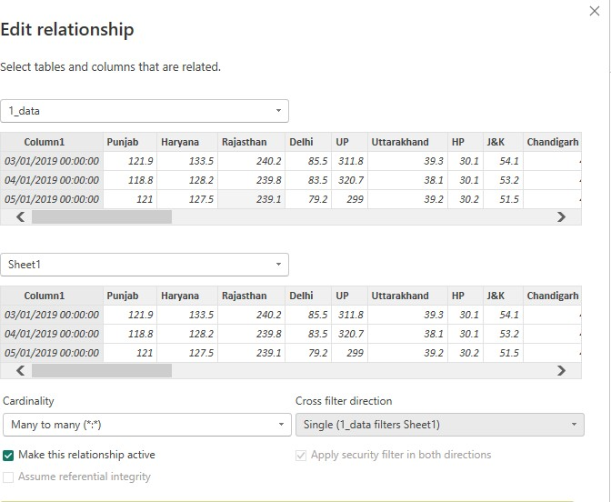

**Dashboard:**

Power consumption of the states during the year 2019 to 2020. Total electricity used by all the states.

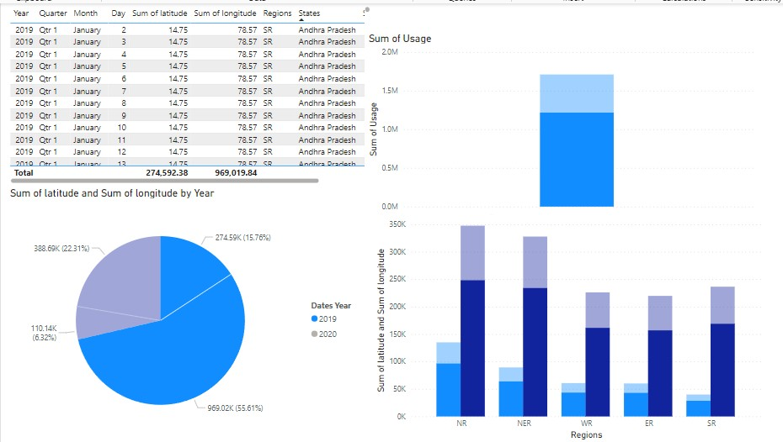

This chart explains the sum of current used by the states like Andhra Pradesh, Delhi, Assam, Bihar, Goa,DNH,Chhattisgarh.

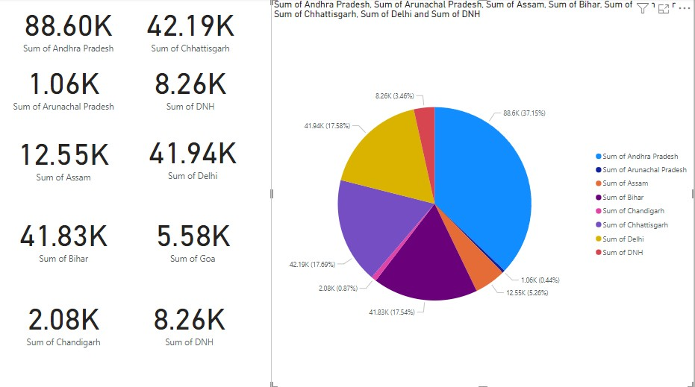

This chart explains the Maximum of current used by all the states listed in the data.

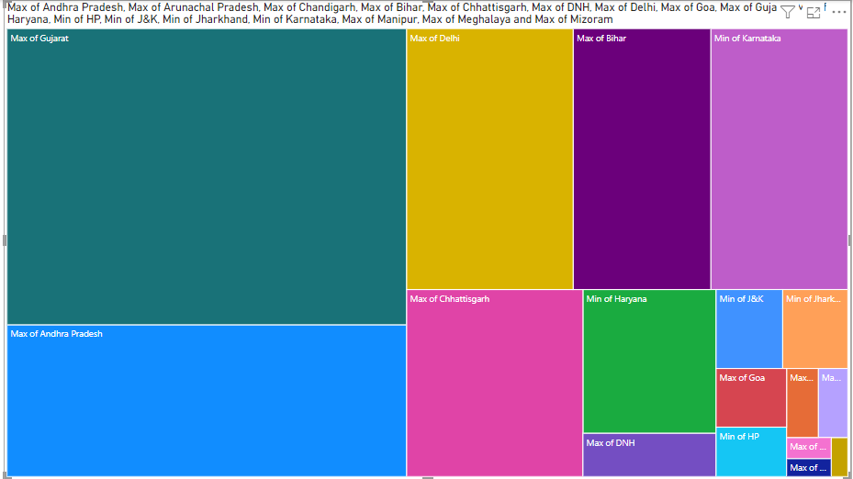

This chart explains the Average usage of the power by the states during the time period of 2019 to 2020.

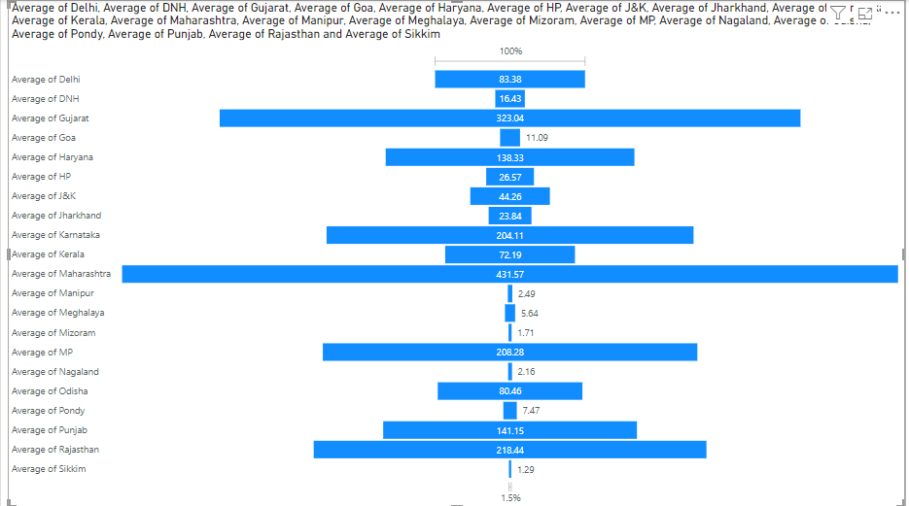

Comparison between the minimum and maximum power consumption between states.

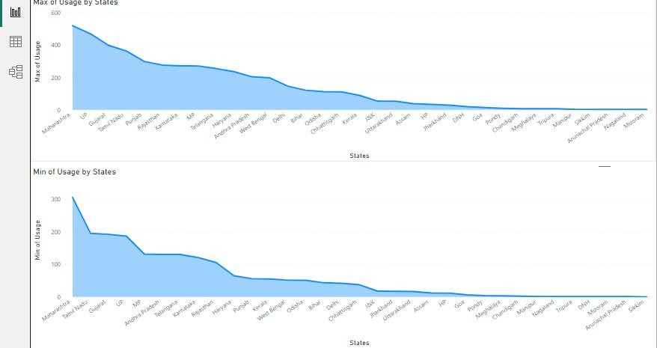

Major states in India are using the electrical power even the government has taken measures to give power energy to villages in the mountains and rural villages.

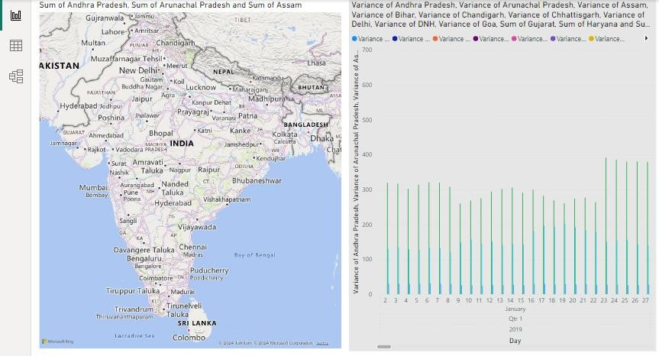

# CONCLUSION

Certainly! In addition to the mentioned benefits, utilizing Power BI for power consumption in India provides a platform for real-time monitoring, enabling prompt response to fluctuations and emergencies. It facilitates data-driven policymaking, fostering collaboration between government agencies, utilities, and industries to address energy challenges effectively. Moreover, by integrating predictive analytics, Power BI can help forecast future consumption patterns, aiding in infrastructure planning and investment decisions to ensure sustainable energy management for the nation's development. In conclusion, leveraging Power BI for analysing power consumption in India offers significant insights into usage patterns, trends, and potential areas for optimization. By visualizing data effectively, stakeholders can make informed decisions, optimize resource allocation, and enhance overall energy efficiency strategies to meet the growing demands of the nation.

# FUTURE SCOPE

The future scope of this project is vast. With the advent of advanced analytics and machine learning, PowerBI can be leveraged to predict future trends based on historical data. Integrating these predictive analytics into the project could enable the bank to anticipate customer needs and proactively offer solutions. Furthermore, PowerBI’s capability to integrate with various data sources opens up the possibility of incorporating more diverse datasets for a more holistic view of customers. As data privacy and security become increasingly important, future iterations of this project should focus on implementing robust data governance strategies. This would ensure the secure handling of sensitive customer data while complying with data protection regulations. Additionally, the project could explore the integration of real-time data streams to provide even more timely and relevant insights. This could potentially transform the way banks interact with their customers, leading to improved customer satisfaction and loyalty.

* CHATGPT

# REFERENCES

* GOVERNMENT WEBSITES
* ONLINE BLOGS
* YOUTUBE VIDEOS
* ONLINE ARTICLES

# LINKS